1.Create a directory project_dir & cd to project_dir

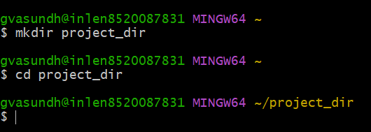

2.Initialize git version database.(git init)

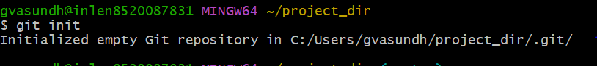

3.Create a new file index.html.

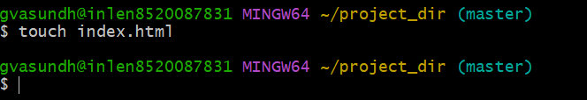

4.Check the git status You should find index.html as untracked file.

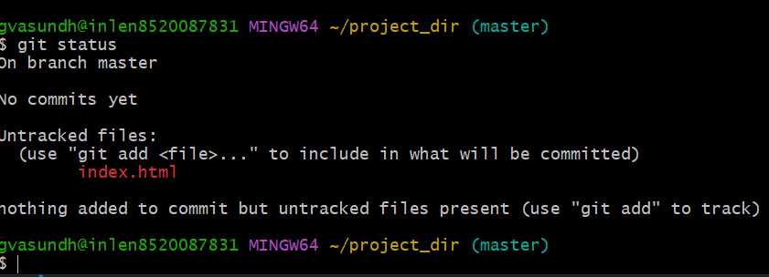

5.Stage the index.html file.

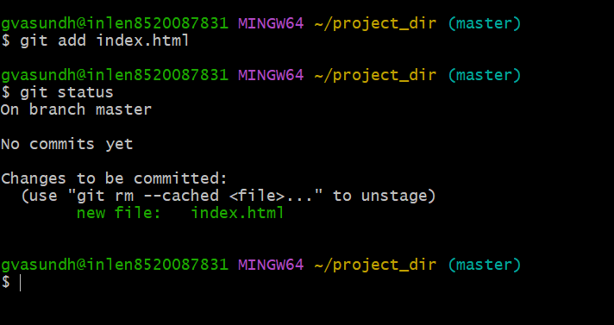

6.Commit index.html

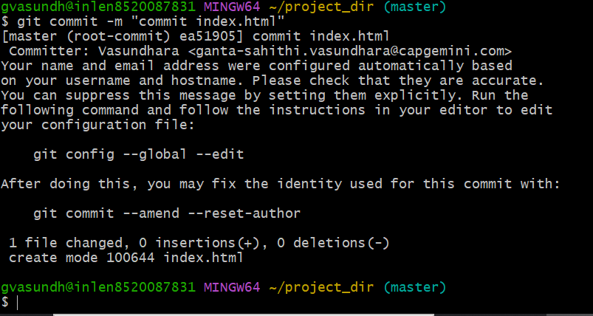

7.Make a few changes in index.html&create a new file info.txt file

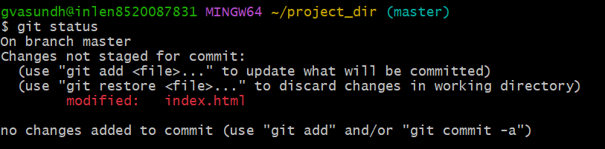

8.Check git status.You should find index.html& create a new file info.txt.file

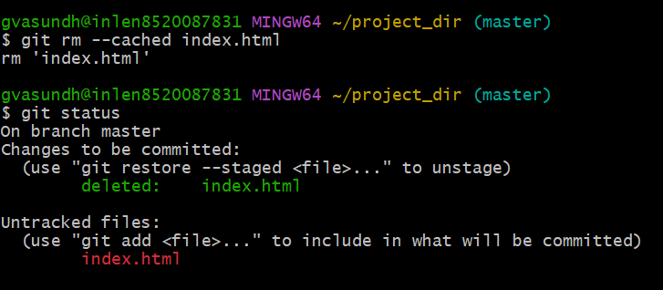

9.configure GIT to ignore all txt files

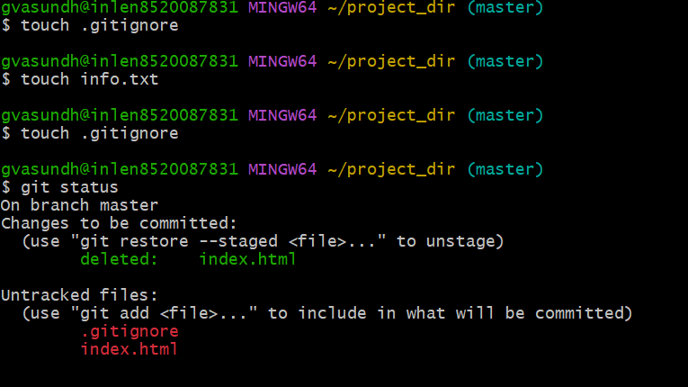

10. Again check the git status You should find only index.html as untracked file

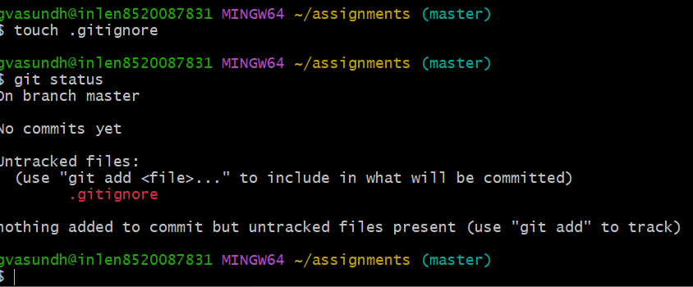

11.State and commit index.html

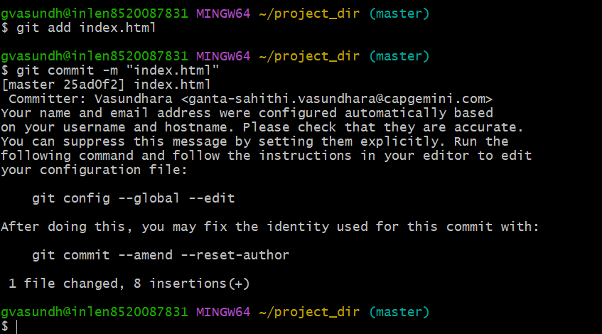

12. Log all your comments so far

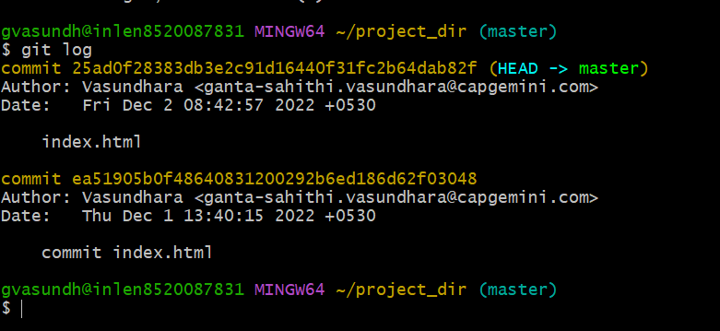

13. Make some changes in index.html

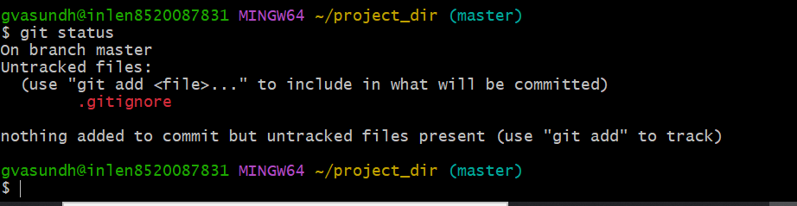

14. Revert the change made in the previous in the step using git command

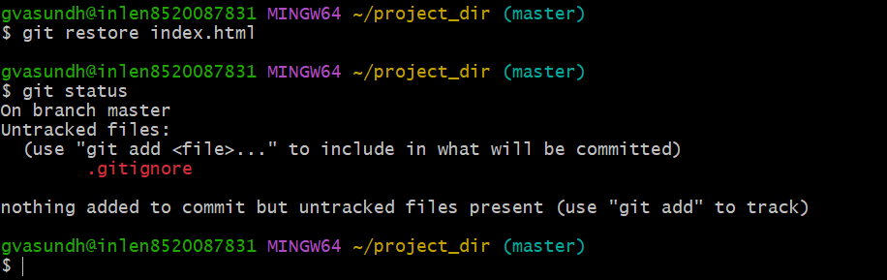

15. Again change index.html

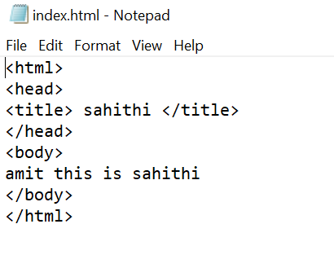

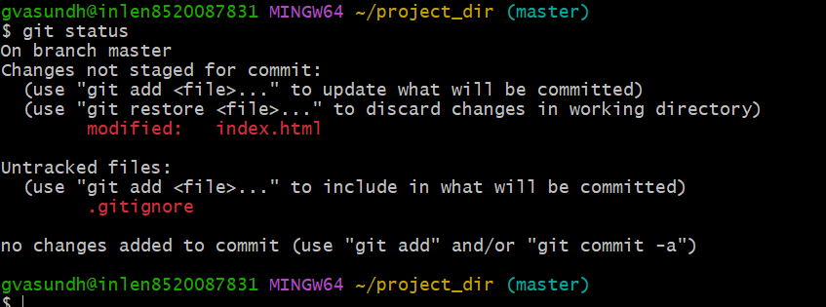

16. Stage index.html

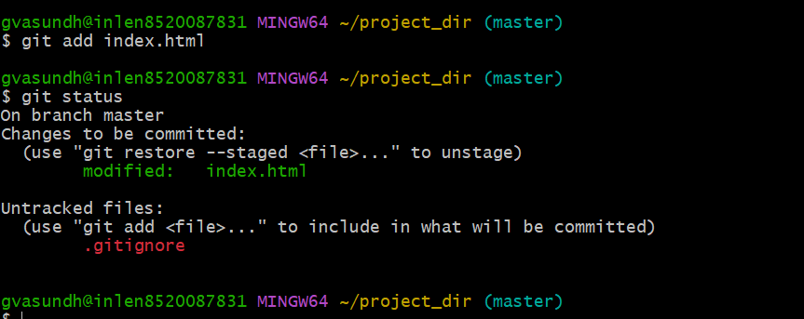

17.Revert back the last stage

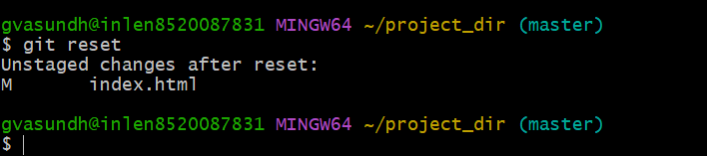

18.Rename add command to my- add .

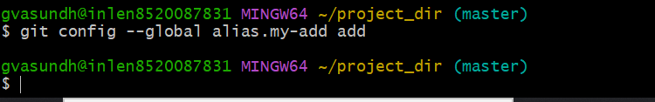

19.Using my_add command Stage index.html again & commit the changes

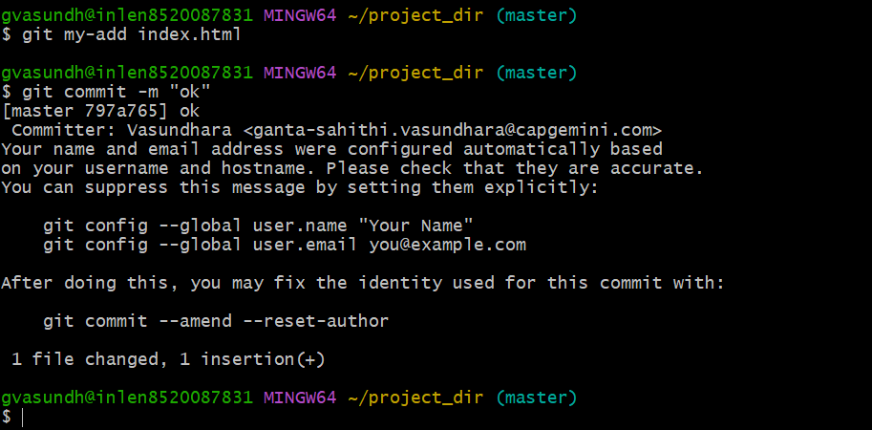

20. Revert the last commit

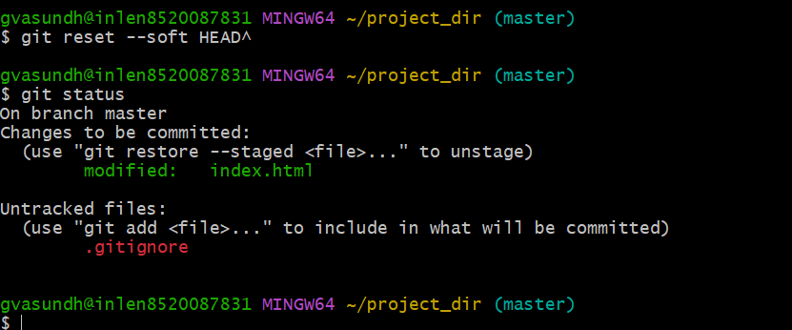

22.Create a empty directory assignments & cd to Assignments

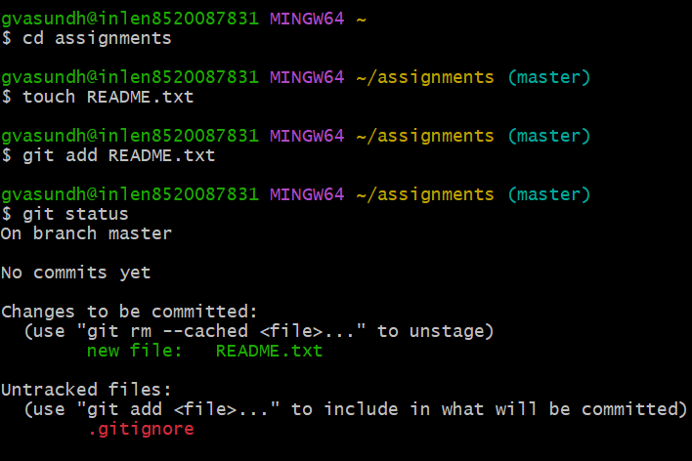

23.Create a README.txt inside Assignments & write few lines about the content of the assignment folder

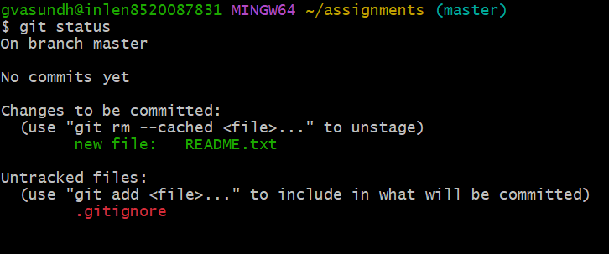

24.commit README.txt file

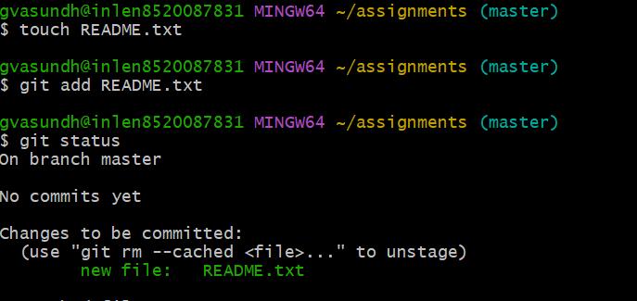

25.now create a new branch in html assignments

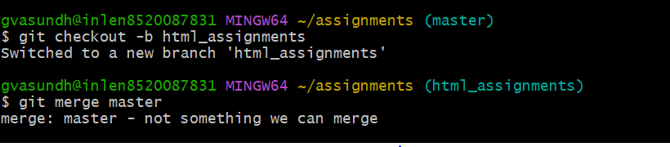

26.switch to html assignment branches

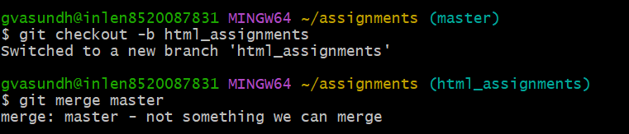

27.copy all html assignments in inside assignments folder

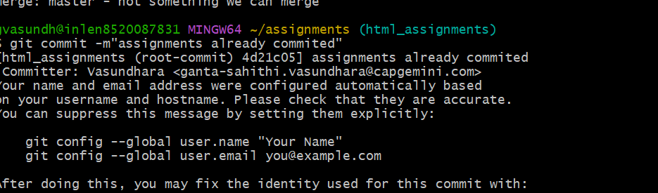

28.commit html assignments into html assignments branch

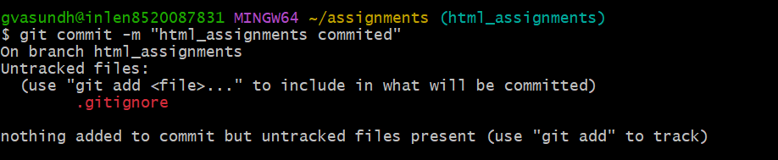

29.Make minor changes into few files belonging to html assinments branch

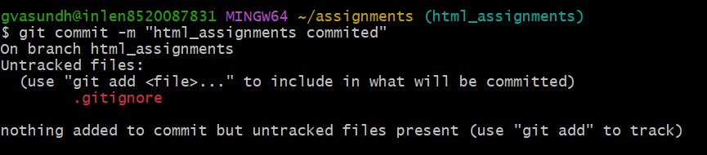

30. Commit those changed lines

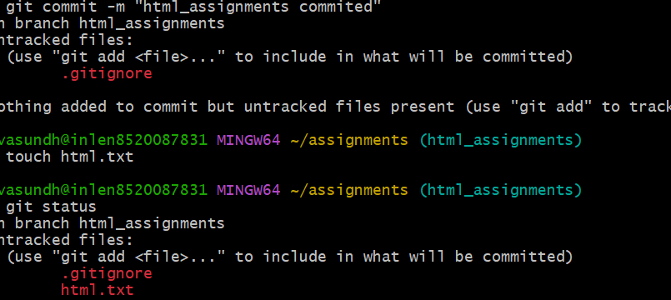

31.Switch to master branch

